PRACTICAL - 4
AIM: Study and apply stepwise project planning activities
Scenario: Airbnb and Farfetch.
Task:
- Study the steps and activities involved in project planning.
- Create project planning for a given scenario

Team Details :
Sr. No. | Name | Enrollment No.
Team Leader | Fenil Shilodre | 202203103510041
Team Member 1 | Gati Shah | 202203103510261
Team Member 2 | Angat Shah | 202203103510097
Team Member 3 | Yash Patel | 202203103510228
Team Member 4 | Sarth Chaudhari | 202303103510106
Project Title : Airbnb System
1. Identify Project Scope and Objectives
- Identify Objectives and Measures of Effectiveness in Meeting Them:
  - Objective:
    - Provide a seamless booking experience for users worldwide.
    - Enable property hosts to efficiently list and manage properties.
    - Ensure secure and fast transactions with integrated payment systems.
    - Support multiple languages and currencies for a global user base.
  - Effectiveness Measure:
    - User satisfaction through surveys and feedback.
    - Increased number of bookings.
    - Platform uptime and performance metrics.
    - Successful processing of payments and security compliance.
- Establish Project Authority:
  - Project manager (Team Leader) is responsible for the oversight, while technical leads will oversee specific modules (frontend, backend, database, security)
- Identify Stakeholders:
  - Airbnb users (guests)
  - Hosts providing experiences
  - Airbnb operations and customer support teams
  - Marketing and Sales teams
  - Technology/Development team
- Modify Objectives in Light of Stakeholder Analysis:
  - Adjustments for local cultural nuances in booking experiences based on different regions.
- Establish Methods of Communication with All Parties:
  - Weekly updates with the team via Slack and bi-weekly meetings for detailed progress reviews.

2. Identify Project Infrastructure
- Establish Relationship Between Project and Strategic Planning:
  - The integration of experiences directly supports Airbnb’s strategy to diversify offerings and increase customer engagement.
- Identify Installation Standards and Procedures:
  - The feature will be built using Airbnb’s existing tech stack (React, Node.js, AWS).
  - Standard procedures will involve using a CI/CD pipeline for updates and testing.
- Identify Project Team Organization:
  - The project team is organized into sub-teams: development, UX/UI, marketing, and testing.

3. Analyze Project Characteristics
- Distinguish the Project as Either Objective-Driven or Product-Driven:
  - The project is product-driven, as it focuses on introducing a new feature for Airbnb users (experience bookings).

- Analyze Other Project Characteristics:
  - The project will be phased, starting with a beta test in a limited region before a global rollout.
- Identify High-Level Project Risks:
  - Risk of low adoption if users do not see value in the experience booking feature.
  - Potential integration issues between the accommodation and activity booking systems.
- Take into Account User Requirements Concerning Implementation:
  - The platform needs to be easy to use, with the ability to filter experiences by location, type, and rating.
- Select General Life-Cycle Approach:
  - The project will use an Agile approach, with sprints lasting 2 weeks, ensuring continuous feedback and improvement.
- Review Overall Resource Estimates:
  - Estimated resources: 4 developers, 2 UX/UI designers, 1 QA tester, 2 marketing professionals. Also include server infrastructure, cloud services and third-party integrations

4. Identify Project Products and Activities
- Identify and Describe Project Products (Including Quality Criteria):
  - Product 1: Web and mobile application
    - Quality criteria: User interface for booking, profile management.
  - Product 2: Payment integration system.
    - Quality criteria: Seamless integration, intuitive UI/UX, reliable transaction process.
- Document Generic Product Flows:
  - Flow 1: User logs in → searches for properties → filters results → makes a booking → payment → receives confirmation.
  - Flow 2: Host lists a property → manages listing → receives booking requests → communicates with guests.

- Recognize Product Instances:
  - Different product instances: Activity categories such as different user profiles (traveler, host, admin) or booking instances (new, canceled, confirmed).
- Produce Ideal Activity Network:
  - Ideal activity flow: Design → Development → Testing → Deployment → Maintenance
  - Activity flow includes system architecture, UI/UX design, database creation, and integration
- Modify Ideal to Take into Account Need for Stages and Checkpoints:
  - Critical checkpoints: Planning → Design → Development → Testing → Deployment → Feedback → Maintenance.

5. Estimate Effort for Each Activity
- Carry Out Bottom-Up Estimates:
  - Estimation based on prior similar feature builds:
    - Front-end development: 120 hours
    - Back-end development: 150 hours
    - UI/UX design: 100 hours
    - Marketing and promotion: 80 hours
- Revise Plan to Create Controllable Activities:
  - The activities are broken into smaller tasks, each reviewed during sprint retrospectives.

6. Identify Activity Risks
- Identify and Quantify Activity-Based Risks:
  - Risk 1: Integration issues with current Airbnb backend (impact: medium).
  - Risk 2: Low user engagement (impact: high).
- Plan Risk Reduction and Contingency Measures Where Appropriate:
  - Develop a contingency plan to enhance the user interface if engagement is low (e.g., additional features like instant booking confirmation).
- Adjust Plans and Estimates to Take Account of Risks:
  - Allocate additional time for troubleshooting potential backend issues.

7. Allocate Resources
- Identify and Allocate Resources:
  - Development: 4 developers, 1 QA tester
  - Design: 2 UX/UI designers
  - Marketing: 2 professionals for outreach and content creation
- Revise Plans and Estimates to Take Account of Resource Constraints:
  - Ensure that the resources allocated to each team are sufficient to meet deadlines while considering potential delays in the design phase.

8. Review/Publicize Plan
- Review Quality Aspects of Project Plan:
  - Ensure that the feature is user-friendly, scalable and adheres to Airbnb’s standards of accessibility and security.
- Document Plans and Obtain Agreement:
  - Present the plan to Airbnb stakeholders (e.g., product managers and executives) for approval.

9/10. Execute Plan/ Lower Levels of Planning
  - Begin development and design sprints, prioritizing core features.
  - Break down the tasks into smaller sub-tasks, assigning them to specific team members.
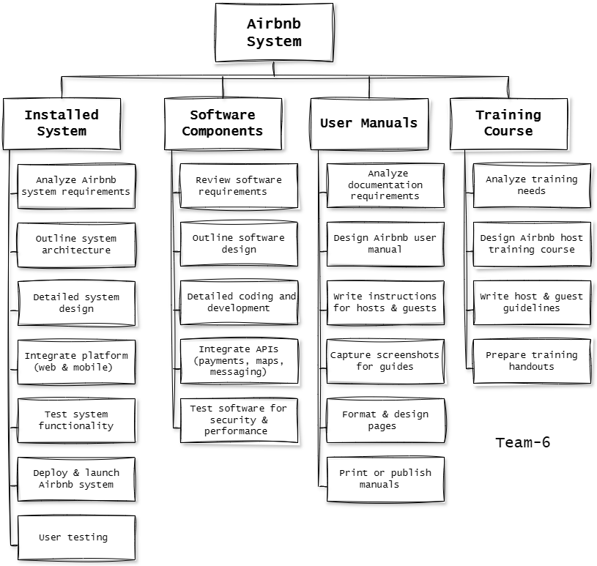
Work Breakdown Structure for AirBnb System

Project Title : Farfetch E-commerce System

1. Identify Project Scope and Objectives
1. Identify objectives and measures of effectiveness in meeting them:
  - Objectives:
    - Create an intuitive and user-friendly platform for luxury fashion shopping.
    - Enable boutiques and brands to list and manage their products.
    - Ensure secure, reliable payment processing and multiple payment options.
    - Provide personalized product recommendations based on customer browsing behavior and preferences.
  - Measures of effectiveness:
    - Customer satisfaction: Measure through customer feedback, reviews, and ratings.
    - Conversion rate: Track the percentage of visitors who complete purchases.
    - Platform uptime: Ensure availability and responsiveness of the platform at all times.
    - Order fulfillment: Monitor delivery times and success rates for global shipping.
2. Establish a project authority:
  - The Project Manager (PM) will oversee the entire project.
  - Technical Leads: Oversee various modules (Frontend, Backend, Payment Systems, etc.).
  - Stakeholders: Users (buyers, boutiques, brands), payment gateways, delivery services, admins.
3. Identify stakeholders:
  - Primary stakeholders:
    - Customers (shoppers who buy luxury fashion products).
    - Boutiques and Brands (sellers listing products).
    - Admins (platform management and oversight).
  - Secondary stakeholders:
    - Payment gateway providers (Stripe, PayPal, etc.).
    - Shipping and logistics partners (FedEx, DHL).
    - Third-party APIs for inventory, recommendations, etc.
    - Compliance and regulatory authorities (GDPR, PCI-DSS).
4. Modify objectives in light of stakeholder analysis:
  - Consider region-specific shipping regulations and payment methods.
  - Enhance personalized recommendations based on data analytics to better match products with customer preferences.
5. Establish methods of communication with all parties:
  - Internal communication: Slack or Microsoft Teams for team collaboration.
  - Stakeholder meetings: Weekly Zoom meetings to discuss project progress, updates, and risks.
  - Project management tools: Jira or Trello to track tasks, milestones, and progress.

2. Identify Project Infrastructure
1. Establish relationship between project and strategic planning:
  - The project supports Farfetch’s business goal of increasing global sales in the luxury fashion market and providing a seamless customer experience.
  - Global scalability: The system must handle a large number of international users, transactions, and product inventories.
2. Identify installation standards and procedures:
  - Cloud infrastructure (AWS, Google Cloud) to handle scaling and ensure high availability.
  - Multi-platform development: Web and mobile app (React Native for iOS and Android).
  - Continuous integration/continuous delivery (CI/CD) for regular updates and testing.

3. Identify project team organization:
  - Project Manager (PM): Leads the project, handles stakeholder communication, ensures deadlines.
  - Technical Leads:
    - Frontend Lead (UI/UX design for web and mobile).
    - Backend Lead (server-side functionality, database, API design).
    - Security Lead (payment security, data privacy).
  - Developers: Full-stack and mobile developers.
  - QA Engineers: Ensuring the platform is bug-free and secure.
  - DevOps: Managing cloud infrastructure, scaling, and deployment.

3. Analyze Project Characteristics
1. Distinguish the project as either objective- or product-driven:
  - Product-driven: The goal is to develop the Farfetch platform where users can shop luxury items and boutiques can list products.
2. Analyze other project characteristics:
  - Medium to large-scale with a global audience, handling high traffic and transactions.
  - Third-party integrations: Payment gateway, shipping services, and recommendation engines.
  - Real-time data: Personalized recommendations, live inventory updates.
  - High availability and scalability required due to international users.
3. Identify high-level project risks:
  - Data breaches: Potential security risks involving user data and payment details.
  - Payment failures or fraud during transactions.
  - Shipping delays or issues with international deliveries.
  - Integration issues: Problems integrating payment gateways or shipping APIs.
4. Take into account user requirements concerning implementation:
  - Functional Requirements:
    - Easy navigation for product search and purchase.
    - Secure payment gateway integration.
    - Global shipping and order tracking.
    - Personalized product recommendations.
  - Non-functional Requirements:
    - Scalability to handle traffic surges, especially during sales events.
    - High availability to ensure the system is up and running 24/7.
    - Data security to protect customer information and prevent fraud.
5. Select general life-cycle approach:
  - Hybrid Agile Approach: Iterative development, allowing flexibility to adjust features based on feedback.
  - Scrum framework for sprint-based development and regular updates.
6. Review overall resource estimates:
  - Personnel: Developers, designers, security experts, DevOps, QA engineers.
  - Technological resources: Cloud infrastructure, payment gateway APIs, shipping service APIs.
  - Financial resources: Budget for cloud services, third-party integrations, marketing campaigns.

4. Identify Project Products and Activities
1. Identify and describe project products (including quality criteria):
  - Products:
    - E-commerce website for browsing and purchasing products.
    - Payment system integration (secure payments via Stripe, PayPal).
    - Product catalog with detailed descriptions, images, and prices.
    - Admin Panel for managing products, users, and orders.
    - Order management system with real-time order tracking.
  - Quality Criteria:
    - User experience: Easy navigation, fast load times, intuitive design.
    - Security: Secure payment processing, encrypted user data.
    - Scalability: Ability to handle large numbers o f users and transactions.
2. Document generic product flows:
  - Customer Flow: Login → Browse Products → Add to Cart → Checkout → Payment → Order Confirmation.
  - Admin Flow: Login → Manage Products → Review Orders → Manage Users.
3. Recognize product instances:
  - User Types: Customers, Admins.
  - Order Status: Pending, Processed, Shipped, Delivered.
4. Produce ideal activity network:
  - Design → Development → Testing → Deployment → Maintenance.
5. Modify ideal to take into account need for stages and checkpoints:
  - Phase 1: Requirements gathering and design (UI/UX, database).
  - Phase 2: Backend and frontend development.
  - Phase 3: API integration (payment, shipping).
  - Phase 4: Testing and quality assurance.
  - Phase 5: Deployment and monitoring.
  - Phase 6: Ongoing maintenance and updates.

5. Estimate Effort for Each Activity
1. Carry out bottom-up estimates:
  - Estimate the time required for each module, such as payment gateway integration, product catalog setup, and user authentication.
2. Revise plan to create controllable activities:
  - Break tasks into manageable sprints (e.g., sprint 1 for product catalog, sprint 2 for payment integration).

6. Identify Activity Risks
1. Identify and quantify activity-based risks:
  - Integration risk: Failure of payment gateway or shipping API.
  - Security risk: Data breaches or fraud during payment transactions.

2. Plan risk reduction and contingency measures:
  - Implement multi-factor authentication (MFA) for payment processing.
  - Use encryption for sensitive data (credit card numbers, addresses).
3. Adjust plans and estimates to take account of risks:
  - Add buffer time for third-party API integration and security testing.

7. Allocate Resources
1. Identify and allocate resources:
  - Personnel: Developers, security specialists, designers, QA engineers.
  - Technology: Cloud infrastructure, payment gateways, shipping APIs.
2. Revise plans and estimates to take account of resource constraints:
  - Adjust plans to ensure timely integration of critical systems, such as the payment gateway.

8. Review/Publicize Plan
1. Review quality aspects of project plan:
  - Ensure all quality aspects (security, scalability, performance) are adequately addressed.
2. Document plans and obtain agreement:
  - Stakeholder sign-off for the project plan to ensure alignment with business goals.

9/10. Execute Plan/Lower Levels of Planning
- Execution:
  - Sprint 1: Set up cloud infrastructure and begin UI/UX design.
  - Sprint 2: Develop product catalog, integrate basic features.
  - Sprint 3: Complete payment system integration, begin testing.
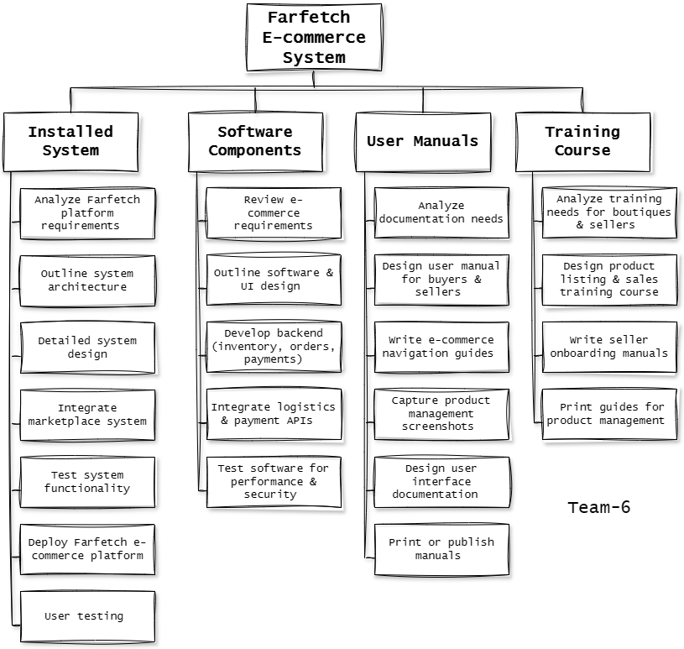
Work Breakdown Structure for FarFetch

